**The streets are yours to live and flourish in. Be brave and be curious. Make new discoveries. Express yourself and inspire those around you. “The Scene” is your street and the street is your road. Embrace it!**

**The Soft Gallery AW15 Collection “The Scene” is all about living with your eyes wide open. It’s about engaging in life. About seeing, feeling …**

Scroll below for product specific size chart.

**Size options:**

* 4 years old
* 6 years old
* 8 years old
* 10 years old
* 12 years old
* 14 years old
* 100% Cotton

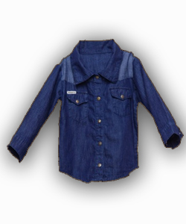**Denim Shirt**

**Materials, Care & Information:**

* Full sleeve
* Machine wash cold with like colors.
* Do not bleach.
* Tumble dry low or hang to dry.
* Warm iron when needed.

## Description:

* The dark reddish-brown in color, which located 5 in front of shirt, 2 on the both pockets and each at the end of the both sleeves.
* The color contract fabric used at the shoulder adds quirkiness.
* 2 styled breast pockets with a flap.

## Cost: SGD 59.90

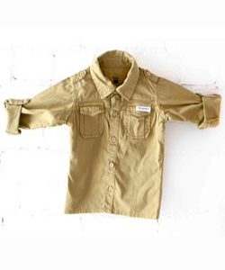

**FRIAS Utility Shirt**

**Materials, Care & Information:**

* Machine Washable
* 100% Cotton
* Keep away from fire

## Description:

* With classic utility styling, this shirt is a timeless staple for his smart/casual wardrobe.
* The shirt is made from pure cotton and features two button down pockets, mock shoulder straps and button tabs on the sleeves.
* Button-through fastening
* Long sleeves

## Cost: SGD 55.90

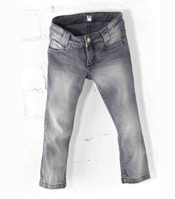**FRIAS Acid Wash Skinny Jeans**

**Materials, Care & Information:**

* Machine Washable
* 82% Cotton, 17% Polyester, 1% Elastane
* Keep away from fire

## Description:

* These skinny fit jeans have an acid wash finish for a trend-driven base for her/his weekend outfits.
* The biker-chic jeans have a comfy skinny fit with a high waist for style and are made with stretch for comfort.
* Button and zip fly fastening
* Skinny fit

## Cost: SGD 69.90